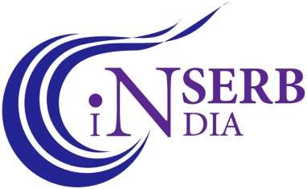 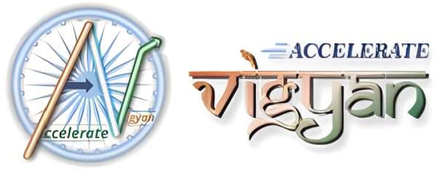



**SERB (KARYASHALA), DST, GoI Sponsored**

**HIGH-END WORKSHOP ON Advanced R Programming in Hydrology for Understating the Impact of Climate Change on Water Resource Management**

**July 18th to July 29th, 2023**

**Organized by**

**Centre for Water Resources Development and Management**

**Kozhikode, Kerala 673 571**

No Objection Certificate

# (From Supervisor/Head of the Department/Principal/Director)

This is to certify that Mr./Ms. …………………………………………………………………………………………………………………

Bearing registration/ Roll No is a bonafide student of

(Institute/ College / University) currently pursuing

his/her (Degree Name) from the department of

(Dept. name)………………………………………………………….….

He/ She may be allowed to attend the SERB (DST) sponsored High-end workshop (KARYASHALA) on “**Advanced R Programming in Hydrology for Understating the Impact of Climate Change on Water Resource Management”** to be held during **July 18th to July 29th, 2023** at KSCSTE – Centre for Water Resources Development and Management, Kozhikode.

The Institute/ College/ University has no objection to permit the above student, if selected, to attend the said workshop in physical mode during the afore-mentioned period.

Date:

Signature with date Supervisor/ HoD/ Principal/ Director (with Official seal/ stamp)